University of Science and Technology
- Wrocław-



LABORATORY 8: UTILIZING SOFTWARE TO ASSIGN AND ACCOUNT FOR TASKS

SUPPORT FOR IT PROJECT MANAGEMENT
2025/2026
Teacher: Piotr Zabawa
Student: Álvaro Puebla Ruisánchez 293867

Table of Contents
Table of Contents 2
1. Software Overview 3
1.1 Name and Purpose 3
1.2 Key Functionality 3
1.3 Why ClickUp Was Selected 4
2. Performed Tasks 5
2.1 Task 1 - Assigning Priority Levels and Descriptions to Each Task 5
2.2 Task 2 - Defining and Implementing Custom Categorization Fields 7
2.3 Task 3 - Reviewing the Schedule in Light of New Metrics 9
3. Summary 11
3.1 Software Suitability Assessment 11
3.2 Evaluation of Software Functionality 11
3.3 User Interface Evaluation 12
3.4 Evaluation of Other Software Attributes 12

1. Software Overview

1.1 Name and Purpose
The software selected for use during this laboratory session is ClickUp, a cloud-based project management and productivity platform developed by ClickUp Inc. ClickUp is designed to serve as an all-in-one task management tool that enables teams to assign, track, and account for work across projects of varying complexity. Its core purpose within the context of IT project management is to provide a centralized environment where tasks can be created, allocated to team members, enriched with descriptive and categorical information, and monitored throughout their lifecycle. In the specific context of this laboratory exercise, ClickUp was employed to improve and extend a previously created project schedule for a small online store. This scenario required assigning priority levels and descriptions to existing tasks, defining custom categorisation fields to support both task allocation and accounting processes, and reassessing the project schedule in light of the newly introduced metrics - all of which ClickUp readily supports.

1.2 Key Functionality
ClickUp offers a comprehensive set of features relevant to task allocation and accounting in IT project management. The most pertinent functionalities utilized or evaluated during this exercise include:
- Task Creation and Organisation: Tasks can be structured hierarchically within Spaces, Folders, Lists, and Subtasks, enabling logical grouping of work items at varying levels of granularity.
- Priority Levels: Each task can be assigned one of four built-in priority designations - Urgent, High, Normal, or Low - providing an immediate visual indication of task criticality across all views.
- Task Descriptions and Subtasks: Rich-text descriptions can be added to any task, and complex tasks can be decomposed into subtasks, clarifying the scope of work required for completion.
- Custom Fields: Users can define project-specific fields of various types (dropdown, rating, number, text, date) to capture additional metadata relevant to allocation or accounting, such as task difficulty or estimated output size.
- User Assignment: Tasks can be assigned to one or multiple team members, making responsibilities explicit and supporting workload distribution decisions.
- Task Status Tracking: Each task can be assigned a status such as "To Do", "In Progress", or "Complete", giving the project manager real-time visibility into execution progress.
- Time Tracking: A built-in timer is available natively for each task, enabling teams to log time spent without requiring third-party plugins.
- Task Dependencies: Allows tasks to be linked so that one task cannot begin until a predecessor is completed, enforcing a logical execution order.
- Timeline and Gantt Chart View: Provides a visual representation of the project schedule including dependencies, useful for reviewing the impact of task reordering decisions.
- Activity History: A full log of changes to each task is maintained, supporting transparency and retrospective analysis.
- Notifications and Reminders: Alerts team members to upcoming deadlines or changes in task status, supporting timely task completion.

1.3 Why ClickUp Was Selected
A comparative evaluation was conducted across four candidate tools: Jira, Asana, Trello, and ClickUp. The selection was based on a functional requirements specification that identified thirteen key task management features, prioritized using the MoSCoW method (Must Have, Should Have, Could Have, Won't Have).

ClickUp emerged as the optimal choice for the following reasons:
- Most complete feature coverage on the free tier: ClickUp natively supports all must-have functionalities - including task creation, user assignment, priority levels, deadlines, status tracking, task dependencies, and custom fields - without requiring a paid subscription or third-party plugins.
- Built-in time tracking: Unlike Jira and Trello, which depend on external plugins for time logging in their free tiers, ClickUp includes a dedicated task timer natively, directly addressing one of the identified should-have requirements.
- Custom field flexibility: ClickUp's custom field system supports multiple data types (ratings, dropdowns, numbers, etc.), enabling the definition of project-specific allocation and accounting metrics that are not constrained to a fixed schema.
- No installation required: As a fully web-based application, ClickUp is immediately accessible via any modern browser, eliminating setup overhead during a laboratory session.
- AI-assisted navigation: ClickUp includes an integrated AI agent capable of directing users to relevant features via natural-language queries, which reduces the time needed to locate specific configuration options.
In comparison, Jira covers all required functionalities but imposes a significant learning curve that is disproportionate for this exercise's scope.
Asana offers strong collaboration features but restricts time tracking and advanced reporting in its free plan. Trello, while simple to use, does not support task dependencies or timeline views in its free tier, making it unsuitable for projects that require dependency management.

In summary, ClickUp provided the most complete and accessible coverage of the defined functional requirements within a cost-free format, making it the most appropriate tool for this academic task allocation and accounting exercise.

2. Performed Tasks

2.1 Task 1 - Assigning Priority Levels and Descriptions to Each Task
Task description:
The first task required opening the previously created project in ClickUp and enriching each existing task with two types of information: a priority level and a textual description (or, where appropriate, a set of subtasks).

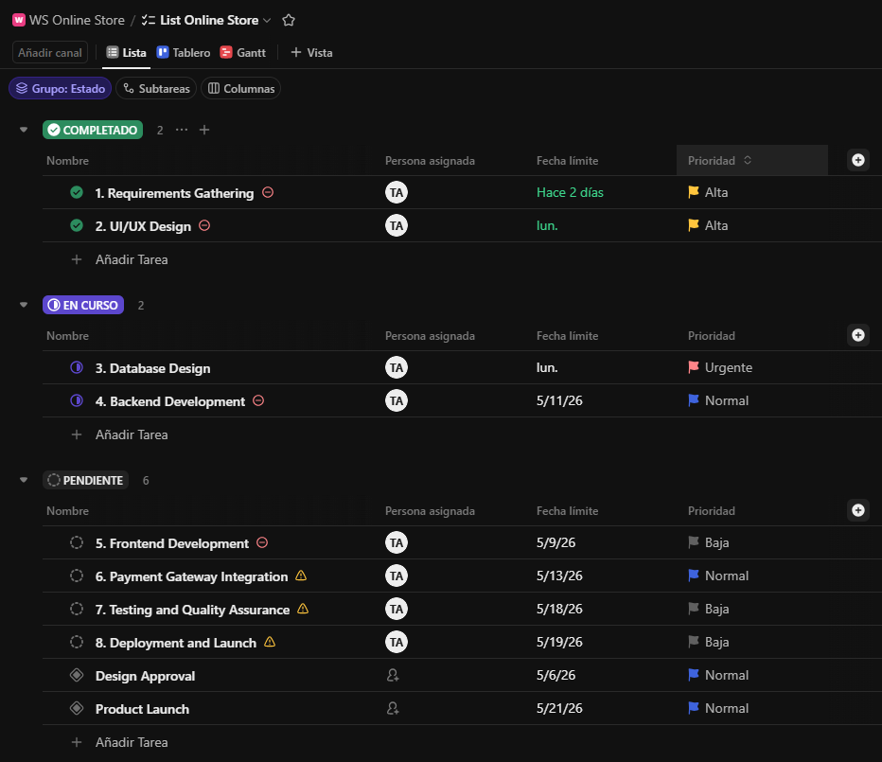
To assign a priority level, each task card was opened individually. Within the task detail panel, the Priority field was located in the right-hand properties column. ClickUp offers four standard priority levels: Urgent, High, Normal, and Low. Each task was assessed according to its criticality within the project and assigned an appropriate level. For example, tasks related to core backend infrastructure or payment processing were assigned the Urgent or High priority, while tasks such as UI styling refinements or optional feature additions received Normal or Low priority respectively. [Figure 1]
Figure 1. Screenshot - ClickUp List view showing tasks with assigned priority levels (Alta/High, Urgente/Urgent, Normal, Baja/Low).

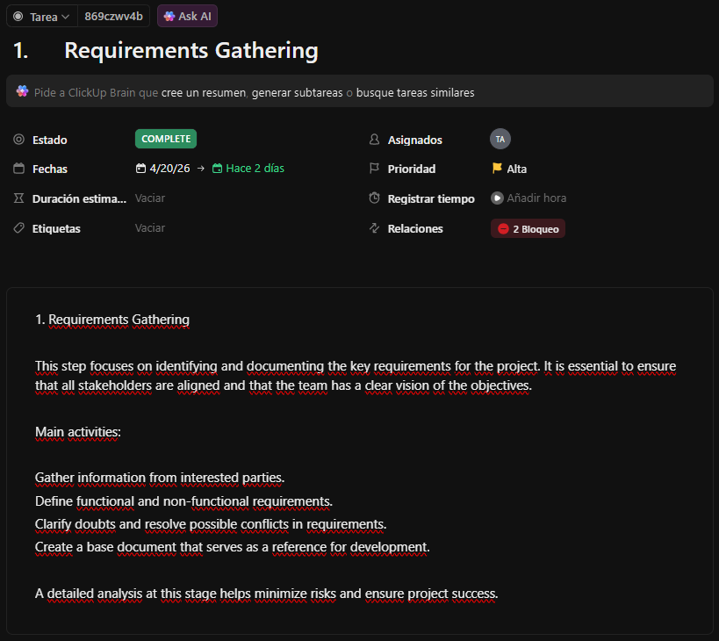
To add descriptions, the description field within each task card was used. For tasks that could be decomposed into distinct steps or deliverables, subtasks were created instead of, or in addition to, a plain description. Subtasks were added via the "Add Subtask" option within the task detail view. This provided a clearer breakdown of the work involved and made it easier to track partial completion. [Figure 2]
Figure 2. Screenshot - Task detail panel for "Requirements Gathering" showing the detailed written description outlining the main activities.
The outcome of this task was a project board in which every task carried an explicit priority designation and a descriptive specification of the work required, bringing the project closer to a state that is ready for formal team assignment.

2.2 Task 2 - Defining and Implementing Custom Categorization Fields
Task description:
The second task involved designing two custom categorisation fields and implementing them within the ClickUp project. The two categories were required to serve distinct purposes: one to support the task allocation process, and the other to support the accounting process.

The following two custom fields were designed and implemented:
- Task Difficulty (Allocation-oriented field) Type: Rating (1-5 scale) Purpose: To express the estimated complexity of a task, enabling the project manager to match tasks to team members of appropriate skill level. A rating of 1 indicates a straightforward task suitable for a junior team member, while a rating of 5 indicates a highly complex task that requires senior expertise. This directly addresses the scenario described in the exemplary task from the presentation, where a team of one senior and two junior developers must be allocated tasks efficiently.
- Estimated Lines of Code (Accounting-oriented field) Type: Dropdown (Small: <100 LOC / Medium: 100-500 LOC / Large: >500 LOC) Purpose: To provide a coarse estimate of the coding effort associated with each task, which can later be compared against actual output as part of the project accounting process.

To implement these fields, the following steps were performed: 1. Navigated to the project List view in ClickUp. 2. Clicked the "+" icon at the right end of the column headers to add a new custom field. 3. Selected "Rating" as the field type for Task Difficulty and configured the scale from 1 to 5. 4. Repeated the process, selecting "Dropdown" for Estimated Lines of Code, and entered the three option values (Small, Medium, Large). 5. Once both fields were created and visible as columns in the List view, each task was opened and assigned a Task Difficulty rating based on the student's assessment of the work involved. [Figure 3]
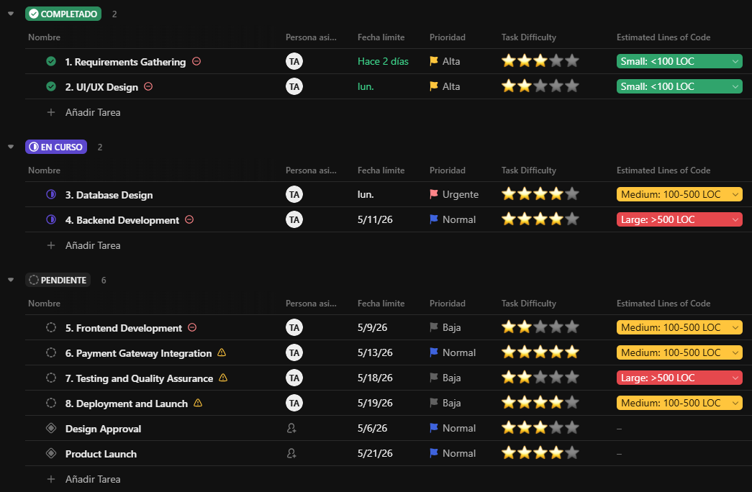
Figure 3. Screenshot - ClickUp List view displaying the two newly created custom field columns: "Task Difficulty" and "Estimated Lines of Code".
Both custom fields were populated for the tasks as required by the exercise. The allocation-oriented field (Task Difficulty) displays ratings from 2 to 5 stars across different tasks, with more complex tasks such as Backend Development and Payment Gateway Integration receiving higher ratings (4-5 stars), while simpler tasks like UI/UX Design received lower ratings (2 stars). The accounting-oriented field (Estimated Lines of Code) was populated with appropriate values: Small (<100 LOC) for Requirements Gathering and UI/UX Design, Medium (100-500 LOC) for Database Design, Payment Gateway Integration, and Deployment tasks, and Large (>500 LOC) for Backend Development and Testing tasks.

2.3 Task 3 - Reviewing the Schedule in Light of New Metrics
Task description:
The third task required a critical review of the project schedule established in the previous laboratory, taking into account the newly introduced Task Difficulty ratings. The objective was to determine whether the existing task ordering and assignment strategy remained appropriate or whether adjustments were warranted.
Upon reviewing the schedule with the Task Difficulty ratings visible, the following observations were made:
- Effective initial sequencing: The schedule begins with Requirements Gathering (difficulty 4 stars), which is appropriately placed as a foundational task despite its complexity. This is followed by UI/UX Design (difficulty 2 stars), providing variety and allowing the team to establish working patterns while completing both critical and less complex work early on. This structure effectively supports the principle of progressive complexity without excessive concentration of high-difficulty tasks at the project outset.
- Balanced workload distribution: The in-progress tasks (Database Design with 4 stars and Backend Development with 5 stars) represent a reasonable concentration. Database Design must logically precede or accompany Backend Development due to data structure dependencies, making their concurrent scheduling both necessary and justified. The pending development tasks are logically ordered, with Frontend Development (2 stars) scheduled before more complex integration and testing tasks, allowing junior developers to build confidence with manageable work before tackling higher-difficulty items.
- Appropriate milestone positioning: The milestones (Design Approval and Product Launch) are correctly positioned at logical project gates. These milestones appropriately carry no "Estimated Lines of Code" values, as they represent approval points and deliverable completions rather than development tasks that generate code. This distinction demonstrates proper understanding of the difference between development tasks and project milestones.
- Sound overall structure maintained: The overall project structure, milestone definitions, and deadline targets were reviewed and found to be well-planned and appropriate. No structural overhaul was deemed necessary. The schedule demonstrates effective planning principles and was retained without modification, as the current ordering already reflects good project management practices. [Figure 4]

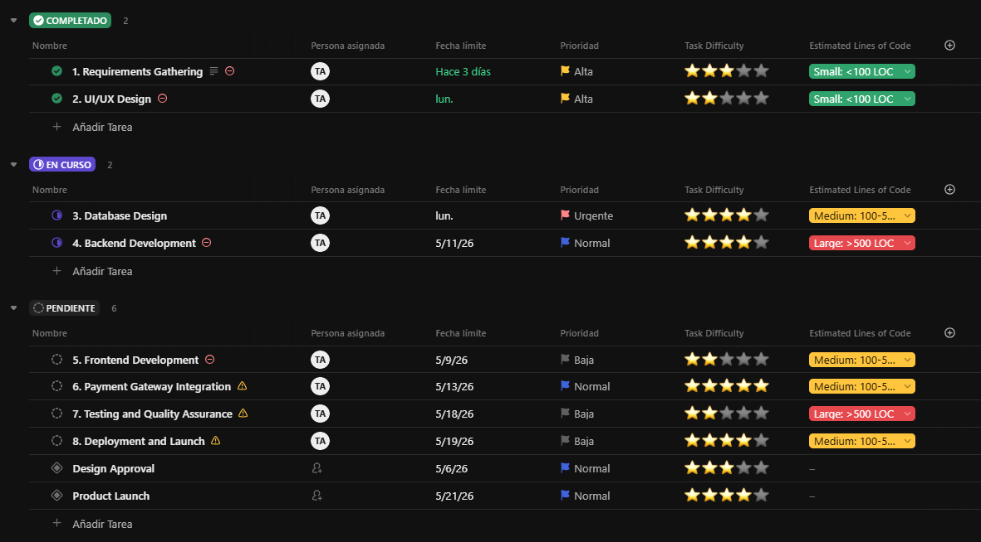
Figure 4. Screenshot - ClickUp List view showing the complete task schedule

The review concluded that the schedule was already well-structured and required no significant adjustments. The effective distribution of task difficulty across the project timeline, combined with proper distinction between development tasks and milestones, supports the principle of progressive complexity escalation.
This sequencing begins with foundational and moderately complex tasks, progressing through high-difficulty development work, and concluding with integration and testing phases-builds team momentum and reduces the probability of early-stage blockers caused by underestimated technical challenges.

3. Summary

3.1 Software Suitability Assessment
ClickUp demonstrates strong suitability for task allocation and accounting in the context of IT project management. It addresses all thirteen functionalities identified in the laboratory specification, covering the full spectrum from basic task creation and user assignment to advanced features such as task dependencies, timeline visualisation, and time logging. The platform is particularly well-suited to small and medium-sized projects, where its free tier provides sufficient capability without requiring financial investment. For larger projects with extended team sizes and more demanding reporting needs, the paid plans offer a cost-effective upgrade path.

The ability to define custom fields is especially relevant for requirements management and task accounting, as it enables project managers to adapt the tool's data model to the specific metrics of their project, rather than being constrained to a fixed set of attributes. This flexibility makes ClickUp a practical choice not only for the exercise performed in this laboratory, but also, for real-world project management scenarios.

3.2 Evaluation of Software Functionality
ClickUp's functionality is comprehensive and, in most respects, exceeds the minimum requirements defined for this exercise. The following observations summarise the quality and usefulness of the key features encountered:
- Task creation and organisation: The hierarchical structure (Spaces > Folders > Lists > Tasks > Subtasks) provides a logical and scalable way to organise work. It supports both simple flat task lists and complex, nested project structures.
- Priority levels and custom fields: The built-in four-level priority system is intuitive and immediately visible in all views. The custom field functionality is flexible, supporting types such as ratings, dropdowns, text, numbers, and dates, which makes it highly adaptable.
- Timeline and Gantt chart: The timeline view provides a clear visual representation of task scheduling and dependencies. In the free tier, some Gantt chart features are restricted, which is a notable limitation for users who rely heavily on this view. However, the available functionality was sufficient for the purposes of this laboratory.
- Time tracking: The built-in timer is a significant advantage over competitors such as Jira and Trello, which require third-party plugins for equivalent functionality in their free tiers.
- Reporting: The reporting and dashboard features are useful but partially gated behind paid plans. For basic progress monitoring, the free tier is adequate; however, teams requiring detailed analytics would need to upgrade.

3.3 User Interface Evaluation
The ClickUp user interface is modern, visually clean, and generally well-organised. The platform offers multiple task views - List, Board, Calendar, Gantt, and Box - which can be switched contextually depending on the user's current need. This flexibility is a significant usability advantage, as different roles within a team may prefer different representations of the same data.
However, ClickUp's interface also presents a non-trivial learning curve. The density of available features, combined with a large number of menus, sidebars, and configuration options, can be overwhelming for first-time users. During the laboratory session, some time was spent navigating to the correct locations for custom field creation and timeline configuration. The AI assistant integrated into the platform proved helpful in this regard, as it was able to direct users to relevant features via natural-language queries.
Once familiarised, the interface becomes efficient to use. The drag-and-drop functionality for task reordering, the inline editing of field values in the List view, and the right-click context menus all contribute to a productive workflow experience.

3.4 Evaluation of Other Software Attributes
Performance: ClickUp performs adequately in a standard web browser environment. Page load times are acceptable for typical project sizes. No significant performance issues were observed during the laboratory session, although the platform is known to experience occasional slowness when handling very large workspaces with thousands of tasks.
Accessibility: The platform is accessible via any modern web browser on any operating system, which is a notable advantage in academic and professional contexts where device heterogeneity is common. A mobile application is also available, though it was not evaluated as part of this exercise.
Collaboration features: The free tier supports collaboration among multiple team members, including shared task views, comment threads on tasks, and mention notifications. These features are sufficient for small teams and educational use cases.
Limitations: The primary limitations of the free tier are the restricted Gantt chart functionality and the absence of unlimited reporting. Additionally, some integrations with third-party tools (such as Google Workspace applications) are only available on paid plans. These limitations do not significantly affect the core task management use case but may become relevant in more demanding professional deployments.
Overall assessment: ClickUp is a well-rounded, capable, and cost-effective tool for task allocation and accounting in IT project management. Its combination of a comprehensive free tier, flexible customisation options, and a modern interface makes it a strong candidate for adoption in both academic exercises and professional projects of small-to-medium scale.

